VR and SciTechM+ First Grade Integration of STEM Curriculum Plan with the Experiential Learning Theory – Lesson A Dividing Fractions

I. Lesson Concept

The learning objectives for MEE division of fraction lesson involves a real-world problem and division of an integer by a unit fraction with supporting visual representation and using virtual reality (Minecraft, 2020). The following problem is given on a virtual worksheet:

“1) Juan Westinghouse was making 3 figgy puddings for the holidays. If the figgy putting was sliced up into pieces of 1/5 of the whole. How many servings of figgy pudding would there be?” (Minecraft WS, 2020 p.1)

In the virtual Minecraft world students see the written problem and construct 3 sets of 5 blocks which represents populates automatically on a virtual slate as 3 ÷ 1/5 = 15. I would follow on with a question as to why the equation makes sense and allow the students to work in groups to come up with explanations using the visual model. I would also prompt the students that there are five 1/5s in 1 (which is also represented in each set of 5 blocks). I would close with explaining that 3 x 5 (3 sets of 5 blocks) equals 15. An added value is also explaining how multiplying the reciprocal will always work in this problem or asking the class to explain the same.

II. STEM Curriculum Connections and Demographics

This is a curriculum planned aimed to facilitate mathematical education, technological application, and principles of science at the first-grade level in public school contexts using Minecraft Education Edition (MEE) and VR. Mathematical content will address TEKS overarching goal of understanding place value, problem solving with adding and subtracting, and composing and decomposing 2d shapes and 3d solids (TEKS, 2020). The technological overarching goals will be centered on developing critical-thinking, problem-solving, and decision-making skills using collection, analysis, and data reporting (TEKS, 2020). Scientific goals will align with the concept of applying elements of scientific investigation and reasoning. Learning events are constructed based on aligning curriculum between the three subjects.

III. Equipment

Integrating virtual reality in an SciTechM+ context requires supportive hardware and software. The identified platform for a SciTechM+ classroom is 2 VR all in one Headsets, 1 Master PC, MEE licenses for approximately 20 users or instances, a projection screen, projection system capable of supporting VR headsets, approximately 20 tablets, a wireless router, and a database server. A third-party maintenance contract for the system as one complete package is also a strong recommendation.

IV. Setup

The classroom setting are approximately 20 workstations for learners. The projection system is placed in the middle of the classroom and suspended form the setting. The projection screen is placed and suspended in front of the classroom. Bluetooth connectivity form the VR headsets to the projector allows for wireless connectivity and transferring of images. Additionally, there may be an option to connect all systems to the server to support a standalone network. One more contributing factor to consider is teacher prep. Teachers using Minecraft Education Edition should complete the MEE educators Beginner, Intermediate, and Advanced courses prior to using MEE to educate students.

V. Clean Up Procedures

After classroom instruction teachers and students will complete clean up procedures. The teacher will instruct students to use dry paper towels to wipe down surfaces of the computer daily. Following dry wipe down, the teacher will hand out towels dampened in soap and water to wipe down tablet surfaces. At the end of the week, the teacher will disinfect all tablets. VR headsets are cleaned after each use. The same process of drying and wiping down the devices will be maintained. Disinfection may occur daily or as recommended by CDC guidelines. Clean-up for the database server and master PC can occur at the same frequency as all other systems.

VI. Safety

There are reported adverse effects to consider in terms of VR and users. Control measures and parental authorization should be implemented and gathered prior to implementation. A consent form should be drafted addressing all reported side effects of users and control measures. The consent form should also provide any relevant school support and policy information in terms of healthcare responsibility and psychological safety. Headsets should be used for one ten-minute instance per learner per class to mitigate headaches, nausea, and dizziness (Dyer et. al, 2018). Other factors to consider are the allocated amount of time for student to engage in educational content on digital screens. An orientation to the VR headset and virtual world interaction should also be developed to support technological integration.

VII. Learning Framework

Virtual reality is a form of simulation and connect to scenario-based education to deliver a formidable educational structure when considering STEM curriculum integration. The medical education community that uses simulation to educate students formats scenario-based education with the (Experiential Learning Theory Fewster-Thune & Batteson, 2018). Through a process of experience, reflection, conceptualization, and experimentation, educators can connect learners with learning objectives and achieve a desired learning outcome (Fewster-Thune & Batteson, 2018). This learning model can be applied to each educational event using VR and all content within the SciTechM+ curriculum.

The flow of each classroom event will begin with the experience. The educator will ask for a volunteer to use the VR headset to accomplish a curricula task. The VR world will be projected onto a projection screen to accomplish an inclusive VR environment and all-student engagement (Huang et. al, 2016). The user will navigate through the virtual task with help from the teachers and students. Once accomplished, the teacher will engage the students in a reflective process based on the task and standards accomplished during the event. The teacher asks open ended question related to the VR task to connect the student with the primary earning objective. The teacher will then establish learning objectives and begin a process of written or verbal instruction which connects the learner with curriculum content. Following the conceptualization phase process and once learning objectives are communicated, the teacher will transition into an experimentation phase where students will independently accomplish a similar task on their own tablets. Assessments are digitally recorded and can be reviewed and corrected by the class as a consortium using their tablets in the next classroom segment. This allows for formative assessment and scaffolding.

VIII. The VR Teaching Process – Model

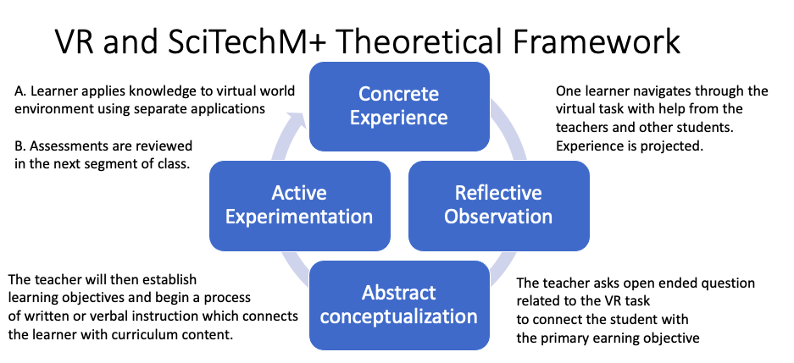

Figure 1: Theoretical approach to VR and SciTechM+ contexts using SBLE. Conceptualized from.
Fewster-Thune & Batteson, (2018)

References:

Dyer, E., Swartzlander, B. J., & Gugliucci, M. R. (2018). Using virtual reality in medical education to teach empathy. Journal of the Medical Library Association, 106(4), 498. https://0-doi-org.lib.utep.edu/10.5195/jmla.2018.518

Fewster-Thune, L. L., & Batteson, T. J. (2018). Kolb's Experiential Learning Theory as a Theoretical Underpinning for Interprofessional Education. Journal of Allied Health, 47(1), 3-8.

Huang, H., Liaw, S., & Lai, C. (2016) Exploring learner acceptance of the use of virtual reality in medical education: a case study of desktop and projection-based display systems, Interactive Learning Environments, 24:1, 3-19, DOI: 10.1080/10494820.2013.817436

Hooks, D., & Heron, A. (2019). Minecraft: Fostering STEM in the Virtual Sandbox. E-Learn 2019, 716–721. Raleigh, NC: AACE.

Kelley, T.R., & Knowles, J.G. (2016). A conceptual framework for integrated STEM education. International STEM Education, 3, 11.

Minecraft. (2020). Dividing Fractions CTF. Retrieved November 19, 2020. from https://education.minecraft.net/lessons/dividing-fractions-ctf-2

Minecraft WS. (2020) 5.NF. 7 Worksheet Dividing Fractions. Retrieved November 19, 2020. from https://education.minecraft.net/lessons/dividing-fractions-ctf-2

Pike J. (2019). 5 NF 7 Dividing Fractions by Whole Numbers in Minecraft Retrieved November 19, 2020. from https://www.youtube.com/watch?v=ZMUijTqiO34

